
AbanteCart Plugin Installation Guide

1) Extract the Plugin File.
2) Copy, Paste and Replace the sub folder each by each of "Admin Folder" and "Catalog Folder" of your AbanteCart web store.
3) Log-in with your Abante-Cart admin panel.
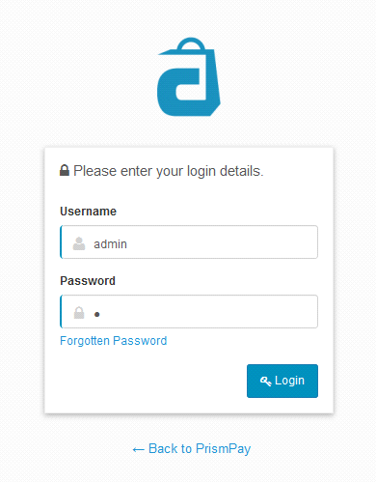

4) Click "Extensions->Payments" at the left menu.

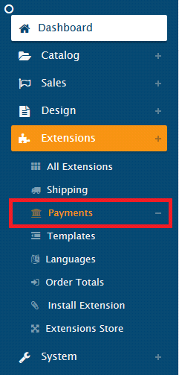

5) Browse for PrismPay and click play button to install it.
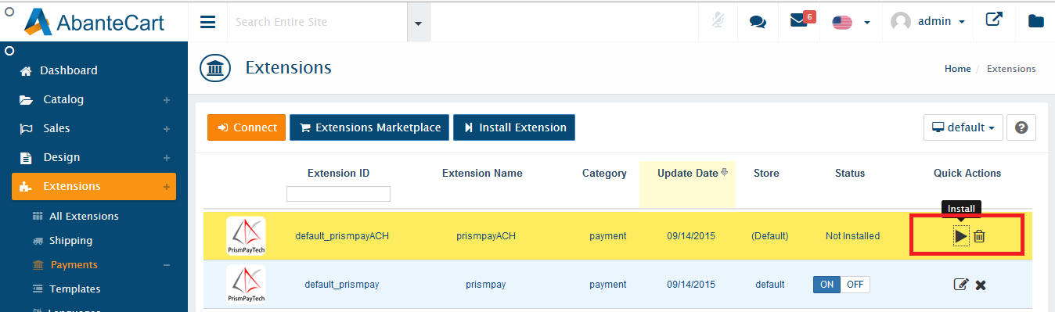

6) Click "Edit Button" to configure it.

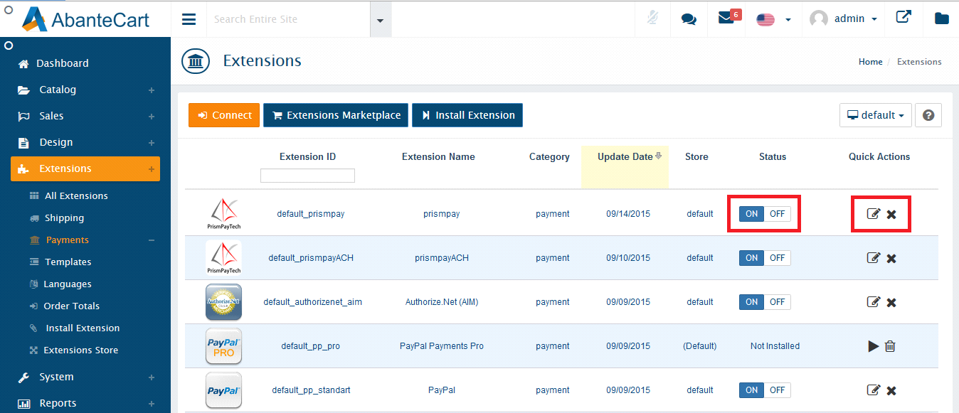

7) Fill out the configuration form and click "Save Button".
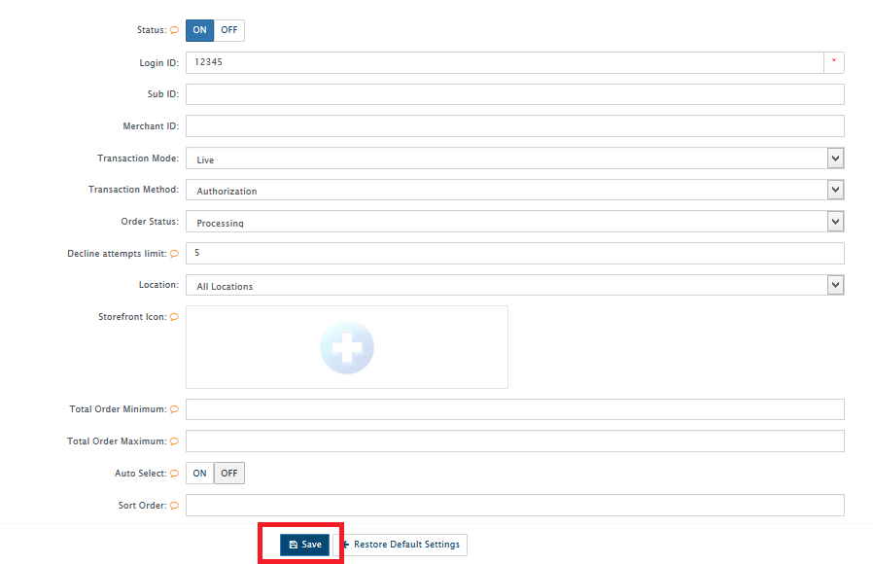

8) Configuration Form required your Prismpay Account Id, Sub Account Id (If available) and Merchant Pin (If available).
9) Set "Transaction Mode" to "Live" and get paid by your customers.

Release Notes:
Current Version: 1.0.1
1) When you install this plugins it enables Credit Card Processing in your AbanteCart online store.
2) This version currently support Credit / Debit Card Processing and E-check processing.
3) This version also support Save Card Profile feature that means users can save their profiles at the gateway and next time they can use that profile to make payments.
4) This version also has a support of Refund Module

